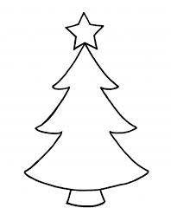
Christmas Crash Courses

Monday 20th Dec – Friday 24th Dec

9:00 Stage 1
09:30 Stage 2
10:00 Stage 3

Monday 27th Dec – Friday 31st Dec

9:00 Stage 1
09:30 Stage 2
10:00 Stage 3

£36.50
Maximum of 8 swimmers per group*
*Except Stage 1 – a maximum of 6

Contact reception now to book
01926 817788

