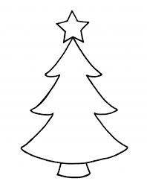
Christmas
Private Lessons

Lessons available with:

Dylan:
Monday 27th– Friday 31st December 10:30am, 11:00am or 11:30am.

Charlotte:
Monday 20th – Thursday 23rd December
09:30am – 12:00pm

Kirsty:
Monday 20th December
09:00am – 12:00pm

1-2-1 £20
2-2-1 £32

Contact reception now to book
01926 817788
(Full payment required upon booking)

